MySQL Create Database

A database is used to store the collection of records in an organized form. It allows us to hold the data into tables, rows, columns, and indexes to find the relevant information frequently. We can access and manage the records through the database very easily.

MySQL implements a database as a directory that stores all files in the form of a table. It allows us to create a database mainly in **two ways**:

1. MySQL Command Line Client
2. MySQL Workbench

MySQL Command Line Client

We can create a new database in MySQL by using the **CREATE DATABASE** statement with the below syntax:

1. **CREATE** **DATABASE** [IF NOT EXISTS] database_name
2. [**CHARACTER** **SET** charset_name]
3. [**COLLATE** collation_name];

**Parameter Explanation**

The parameter descriptions of the above syntax are as follows:

**Example**

Let us understand how to create a database in MySQL with the help of an example. Open the MySQL console and write down the password, if we have set during installation. Now we are ready to create a database. Here, we are going to create a database name **"employeedb"** using the following statement:

1. mysql> **CREATE** **DATABASE** employeesdb;

It will look like the below output:

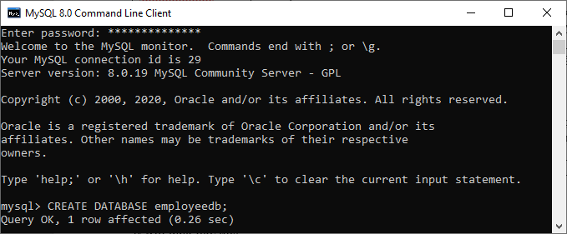

We can review the newly created database using the below query that returns the database name, character set, and collation of the database:

1. mysql> SHOW **CREATE** **DATABASE** employeedb;

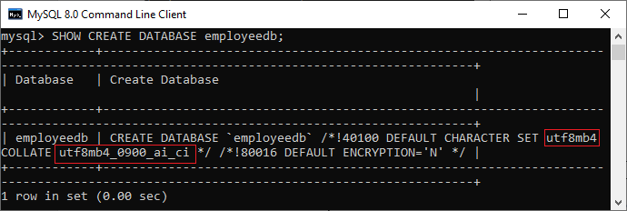

We can check the created database using the following query:

1. mysql> SHOW DATABASES;

After executing the above query, we can see all the created databases in the server.

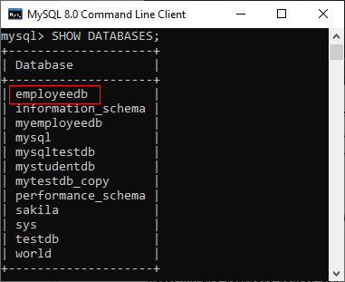

Finally, we can use the below command to access the database that enables us to create a table and other database objects.

1. mysql> USE emplyeedb;

NOTE: All the database names, table names, and table field names are case sensitive. We must have to use proper names while giving any SQL command.

MySQL Workbench

It is a visual database designing or GUI tool used to work with database architects, developers, and Database Administrators. This visual tool supports [SQL](https://www.javatpoint.com/sql-tutorial) development, data modeling, data migration, and comprehensive administration tools for server configuration, user administration, backup, and many more. It allows us to create new physical data models, E-R diagrams, and SQL development (run queries, etc.).

To create a new database using this tool, we first need to launch the [MySQL Workbench](https://www.javatpoint.com/mysql-workbench) and log in using the username and password that you want. It will show the following screen:

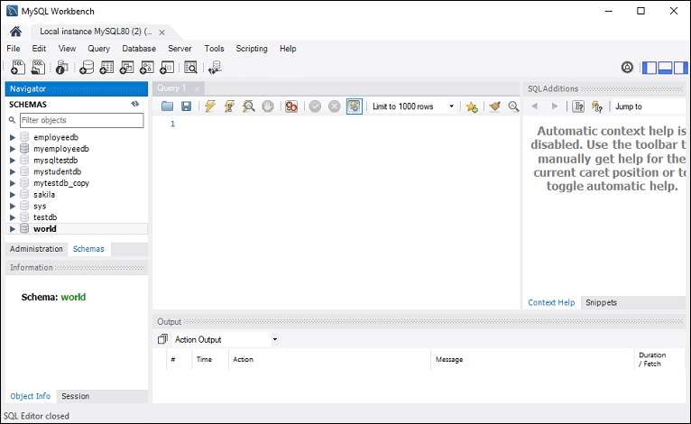

Now do the following steps for database creation:

1. Go to the Navigation tab and click on the **Schema menu**. Here, we can see all the previously created databases. If we want to create a new database, right-click under the Schema menu and select Create Schema or click the database **icon (red rectangle)**, as shown in the following screen.

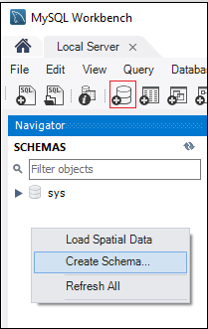

2. The new Schema window screen open. Enter the new database name (for example, **employeedb**) and use default character set and collation. Now, click on the Apply button as shown in the screen below:

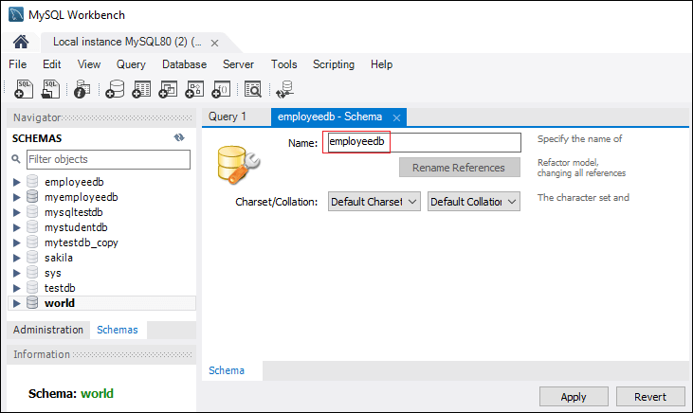

3. A new popup window appears. Click on the **Apply** button.

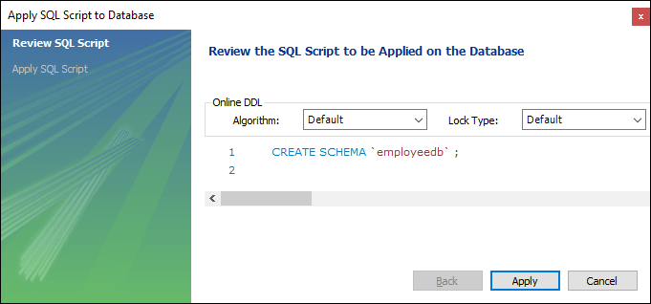

4. A new popup screen appears. Click on the **Finish** button to complete the database creation.

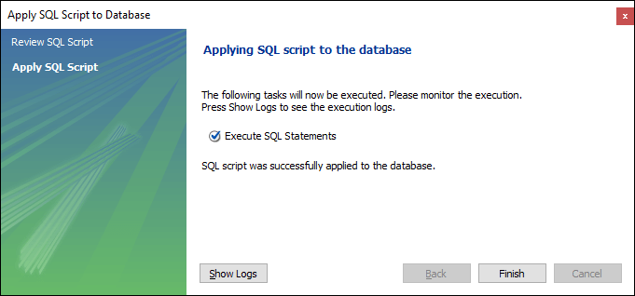

5. After successful database creation, we can see new databases in the Schema menu. If we do not see this, click on the **refresh icon** into the Schema menu.

6. We can see more information about the database by selecting the database and click on the **'i'** icon. The information window displays several options, like Table, Triggers, Indexes, Users, and many more.

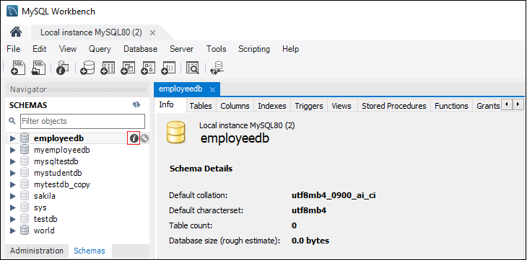

7. MySQL Workbench does not provide an option to rename the database name, but we can create, update, and delete the table and data rows from the database.

MySQL CREATE TABLE

A table is used to organize data in the form of rows and columns and used for both storing and displaying records in the structure format. It is similar to worksheets in the spreadsheet application. A table creation command requires **three things**:

* Name of the table
* Names of fields
* Definitions for each field

MySQL allows us to create a table into the database mainly in **two ways**:

1. MySQL Command Line Client
2. MySQL Workbench

MySQL Command Line Client

[MySQL](https://www.javatpoint.com/mysql-tutorial) allows us to create a table into the database by using the [**CREATE TABLE**](https://www.javatpoint.com/mysql-create-table) command. Following is a generic **syntax** for creating a MySQL table in the database.

1. **CREATE** **TABLE** [IF NOT EXISTS] table_name(
2. column_definition1,
3. column_definition2,
4. ........,
5. table_constraints
6. );

**Parameter Explanation**

Play Video

The parameter descriptions of the above syntax are as follows:

|  |  |
| --- | --- |
| **Parameter** | **Description** |
| database_name | It is the name of a new table. It should be unique in the MySQL database that we have selected. The **IF NOT EXIST** clause avoids an error when we create a table into the selected database that already exists. |
| column_definition | It specifies the name of the column along with data types for each column. The columns in table definition are separated by the comma operator. The syntax of column definition is as follows: **column_name1 data_type(size) [NULL | NOT NULL]** |
| table_constraints | It specifies the table constraints such as PRIMARY KEY, UNIQUE KEY, FOREIGN KEY, CHECK, etc. |

**Example**

Let us understand how to create a table into the database with the help of an example. Open the MySQL console and write down the password, if we have set during installation. Now open the database in which you want to create a table. Here, we are going to create a table name **"employee_table"** in the database **"employeedb"** using the following statement:

1. mysql> **CREATE** **TABLE** employee_table(
2. id **int** NOT NULL AUTO_INCREMENT,
3. **name** **varchar**(45) NOT NULL,
4. occupation **varchar**(35) NOT NULL,
5. age **int** NOT NULL,
6. **PRIMARY** **KEY** (id)
7. );

NOTE:  
1. Here, NOT NULL is a field attribute, and it is used because we don't want this field to be NULL. If we try to create a record with a NULL value, then MySQL will raise an error.  
2. The field attribute AUTO_INCREMENT specifies MySQL to go ahead and add the next available number to the id field. PRIMARY KEY is used to define a column's uniqueness. We can use multiple columns separated by a comma to define a primary key.

**Visual representation of creating a MySQL table:**

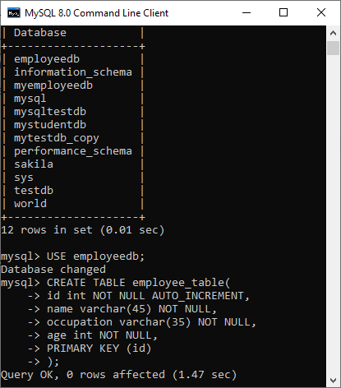

We need to use the following command to see the newly created table:

1. mysql> SHOW TABLES;

It will look like the below output:

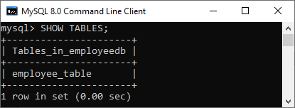

**See the table structure:**

We can use the following command to see the information or structure of the newly created table:

1. mysql> DESCRIBE employee_table;

It will look like this:

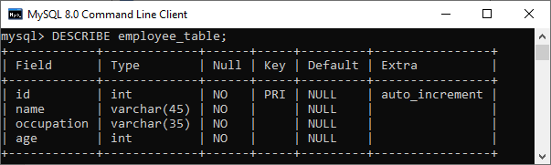

Create Table Using MySQL Workbench

It is a visual GUI tool used to create databases, tables, indexes, views, and stored procedures quickly and efficiently. To create a new database using this tool, we first need to launch the [MySQL Workbench](https://www.javatpoint.com/mysql-workbench) and log in using the username and password that you want. It will show the following screen:



Now do the following steps for table creation:

1. Go to the Navigation tab and click on the **Schema menu**. Here, we can see all the previously created databases. Now we are ready to select the database in which a table is created.

2. Select the database, double click on it, and we will get the sub-menu under the database. These **sub-menus** are Tables, Views, Functions, and Stored Procedures, as shown in the below screen.

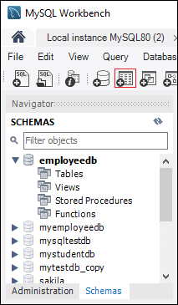

3. Select Tables sub-menu, right-click on it, and select **Create Table** option. We can also click on create a new table icon (shown in red rectangle) to create a table.

4. On the new table screen, we need to fill all the details to create a table. Here, we will enter the table name (**for example**, employee_table) and use default collation and engine.

5. Click inside the middle window and fill the column details. Here, the column name contains many attributes such as Primary Key(PK), Not Null (NN), Unique Index (UI), Binary(B), Unsigned Data type(UN), Auto Incremental (AI), etc. The following screen explains it more clearly. After filling all the details, click on the **Apply** button.

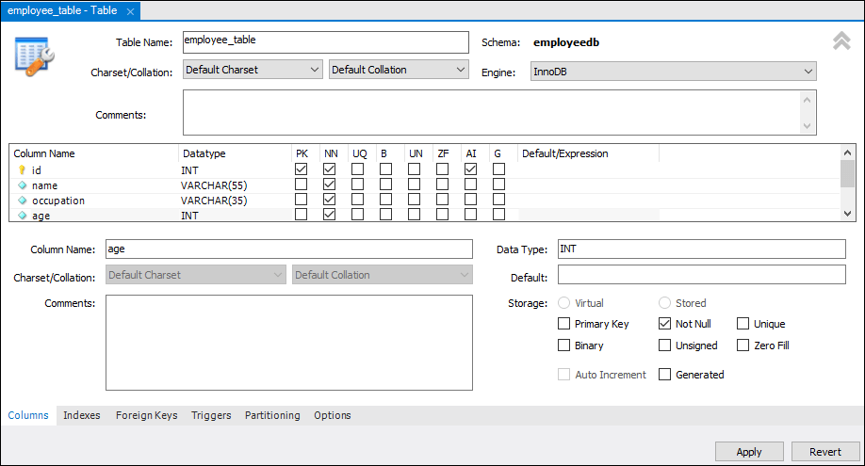

6. As soon as you click on the Apply button, it will open the SQL statement window. Again, click on the Apply button to execute the statement and **Finish** button to save the changes.

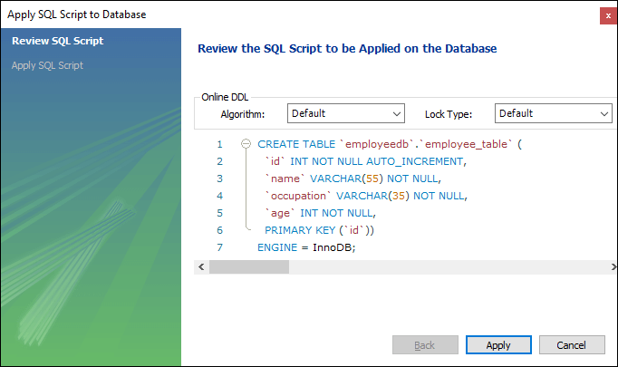

7. Now, go to the Schema menu and select the database which contains the newly created table, as shown in the screen below.

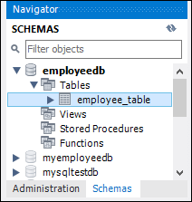

MySQL INSERT Statement

MySQL INSERT statement is used to store or add data in MySQL table within the database. We can perform insertion of records in two ways using a single query in MySQL:

1. Insert record in a single row
2. Insert record in multiple rows

Syntax:

The below is generic syntax of **SQL INSERT INTO** command to insert a single record in [MySQL](https://www.javatpoint.com/mysql-tutorial) table:

1. **INSERT** **INTO** table_name ( field1, field2,...fieldN )
2. **VALUES**
3. ( value1, value2,...valueN );

In the above syntax, we first have to specify the table name and list of comma-separated columns. Second, we provide the list of values corresponding to columns name after the VALUES clause.

NOTE: Field name is optional. If we want to specify partial values, the field name is mandatory. It also ensures that the column name and values should be the same. Also, the position of columns and corresponding values must be the same.

If we want to insert **multiple records** within a single command, use the following statement:

1. **INSERT** **INTO** table_name **VALUES**
2. ( value1, value2,...valueN )
3. ( value1, value2,...valueN )
4. ...........
5. ( value1, value2,...valueN );

In the above syntax, all rows should be separated by commas in the value fields.

MySQL INSERT Example

Let us understand how [INSERT statements](https://www.javatpoint.com/mysql-insert) work in MySQL with the help of multiple examples. First, create a table "**People**" in the database using the following command:

1. **CREATE** **TABLE** People(
2. id **int** NOT NULL AUTO_INCREMENT,
3. **name** **varchar**(45) NOT NULL,
4. occupation **varchar**(35) NOT NULL,
5. age **int**,
6. **PRIMARY** **KEY** (id)
7. );

**1.** If we want to store single records for all fields, use the syntax as follows:

1. **INSERT** **INTO** People (id, **name**, occupation, age)
2. **VALUES** (101, 'Peter', 'Engineer', 32);

**2.** If we want to store multiple records, use the following statements where we can either specify all field names or don't specify any field.

1. **INSERT** **INTO** People **VALUES**
2. (102, 'Joseph', 'Developer', 30),
3. (103, 'Mike', 'Leader', 28),
4. (104, 'Stephen', 'Scientist', 45);

**3.** If we want to store records without giving all fields, we use the following **partial field** statements. In such case, it is mandatory to specify field names.

1. **INSERT** **INTO** People (**name**, occupation)
2. **VALUES** ('Stephen', 'Scientist'), ('Bob', 'Actor');

In the below output, we can see that all INSERT statements have successfully executed and stored the value in a table correctly.

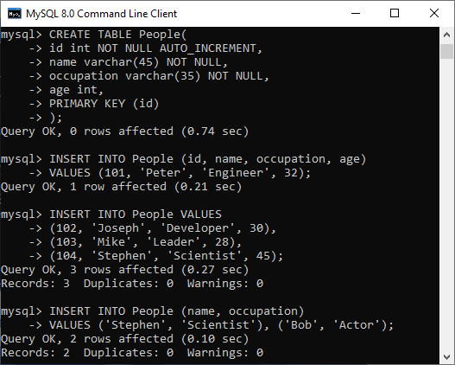

We can use the below syntax to show the records of the **People** table:

1. mysql> **SELECT** * **FROM** People;

We will get the output as follows:

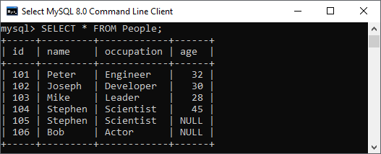

Inserting Date in MySQL Table:

We can also use the INSERT STATEMENT to add the date in MySQL table. MySQL provides several data types for storing dates such as DATE, TIMESTAMP, DATETIME, and YEAR. The **default forma**t of the date in MySQL is **YYYY-MM-DD**.

This format has the below descriptions:

* **YYYY:** It represents the four-digit year, like 2020.
* **MM:** It represents the two-digit month, like 01, 02, 03, and 12.
* **DD:** It represents the two-digit day, like 01, 02, 03, and 31.

Following is the basic syntax to insert date in MySQL table:

1. **INSERT** **INTO** table_name (column_name, column_date) **VALUES** ('DATE: Manual Date', '2008-7-04');

If we want to insert a date in the mm/dd/yyyy format, it is required to use the below statement:

1. **INSERT** **INTO** table_name **VALUES** (STR_TO_DATE(date_value, format_specifier));

MySQL UPDATE Query

MySQL UPDATE query is a DML statement used to modify the data of the MySQL table within the database. In a real-life scenario, records are changed over a period of time. So, we need to make changes in the values of the tables also. To do so, it is required to use the UPDATE query.

The UPDATE statement is used with the **SET** and [**WHERE** clauses](https://www.javatpoint.com/mysql-where). The SET clause is used to change the values of the specified column. We can update single or multiple columns at a time.

Syntax

Following is a generic syntax of UPDATE command to modify data into the [MySQL](https://www.javatpoint.com/mysql-tutorial) table:

1. **UPDATE** table_name
2. **SET** column_name1 = new-value1,
3. column_name2=new-value2, ...
4. [**WHERE** Clause]

Parameter Explanation

The description of parameters used in the syntax of the UPDATE statement is given below:

Play Video

|  |  |
| --- | --- |
| **Parameter** | **Descriptions** |
| table_name | It is the name of a table in which we want to perform updation. |
| column_name | It is the name of a column in which we want to perform updation with the new value using the SET clause. If there is a need to update multiple columns, separate the columns with a comma operator by specifying the value in each column. |
| WHERE Clause | It is optional. It is used to specify the row name in which we are going to perform updation. If we omit this clause, MySQL updates all rows. |

**Note:**

* This statement can update values in a single table at a time.
* We can update single or multiple columns altogether with this statement.
* Any condition can be specified by using the WHERE clause.
* WHERE clause is very important because sometimes we want to update only a single row, and if we omit this clause, it accidentally updates all rows of the table.

The UPDATE command supports these modifiers in MySQL:

**LOW_PRIORITY:** This modifier instructs the statement to delay the UPDATE command's execution until no other clients reading from the table. It takes effects only for the storage engines that use only table-level locking.

**IGNORE:** This modifier allows the statement to do not abort the execution even if errors occurred. If it finds **duplicate-key** conflicts, the rows are not updated.

Therefore, the full syntax of [UPDATE statement](https://www.javatpoint.com/mysql-update) is given below:

1. **UPDATE** [LOW_PRIORITY] [**IGNORE**] table_name
2. **SET** column_assignment_list
3. [**WHERE** condition]

Example:

Let us understand the UPDATE statement with the help of various examples. Suppose we have a table **"trainer"** within the **"testdb"** database. We are going to update the data within the "trainer" table.

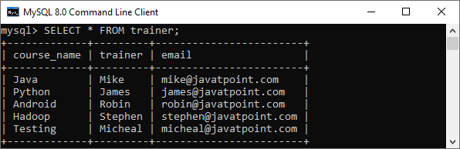

**Update Single Column**

This query will update the **email id of Java** course with the new id as follows:

1. **UPDATE** trainer
2. **SET** email = 'mike@tutorialandexamples.com'
3. **WHERE** course_name = 'Java';

After successful execution, we will verify the table using the below statement:

1. **SELECT** * **FROM** trainer;

In the output, we can see that our table is updated as per our conditions.

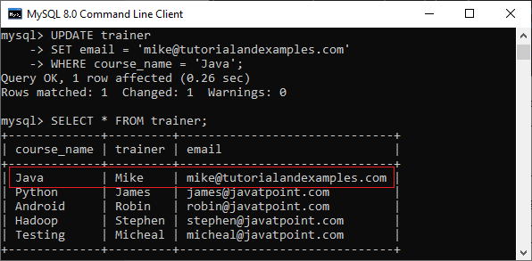

**Update Multiple Columns**

The UPDATE statement can also be used to update multiple columns by specifying a comma-separated list of columns. Suppose we have a table as below:

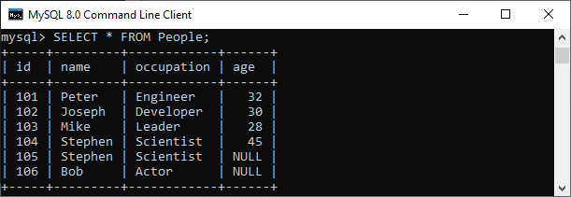

This statement explains will update the **name** and **occupation** whose **id = 105** in the **People** table as follows:

1. **UPDATE** People
2. **SET** **name** = 'Mary', occupation = 'Content Writer'
3. **WHERE** id = 105;

We can verify the output below:

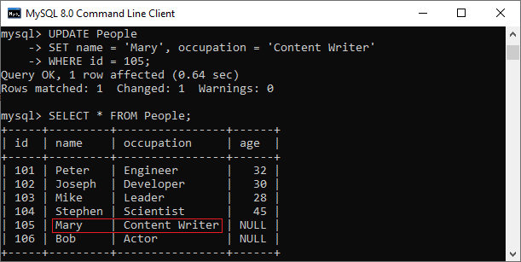

**UPDATE Statement to Replace String**

We can also use the UPDATE statement in MySQL to change the string name in the particular column. The following example updates the domain parts of emails of **Android course:**

1. **UPDATE** Trainer_table
2. **SET** email = REPLACE(email,'@javatpoint.com','@tutorialandexample.com')
3. **WHERE** course_name = 'Testing';

It will give the following output:

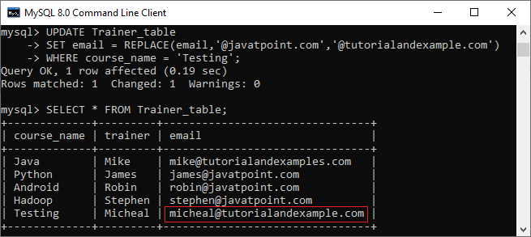

MySQL DELETE Statement

MySQL DELETE statement is used to remove records from the MySQL table that is no longer required in the database. **This query in MySQL deletes a full row from the table and produces the count of deleted rows**. It also allows us to delete more than one record from the table within a single query, which is beneficial while removing large numbers of records from a table. By using the delete statement, we can also remove data based on conditions.

**Once we delete the records using this query, we cannot recover it**. Therefore before deleting any records from the table, it is recommended to **create a backup of your database**. The database backups allow us to restore the data whenever we need it in the future.

**Syntax:**

The following are the syntax that illustrates how to use the DELETE statement:

Play Video

1. **DELETE** **FROM** table_name **WHERE** condition;

In the above statement, we have to first specify the table name from which we want to delete data. Second, we have to specify the condition to delete records in the [WHERE clause](https://www.javatpoint.com/mysql-where), which is optional. If we omit the WHERE clause into the statement, this query will remove whole records from the database table.

If we want to delete records from multiple tables using a single DELETE query, we must add the [**JOIN**](https://www.javatpoint.com/mysql-join)**clause** with the DELETE statement.

If we want to delete all records from a table without knowing the count of deleted rows, we must use the [**TRUNCATE TABLE**](https://www.javatpoint.com/mysql-truncate-table) statement that gives better performance.

Let us understand how the DELETE statement works in [MySQL](https://www.javatpoint.com/mysql-tutorial) through various examples.

MySQL DELETE Statement Examples

Here, we are going to use the **"Employees"** and **"Payment"** tables for the demonstration of the DELETE statement. Suppose the Employees and Payment tables contain the following data:

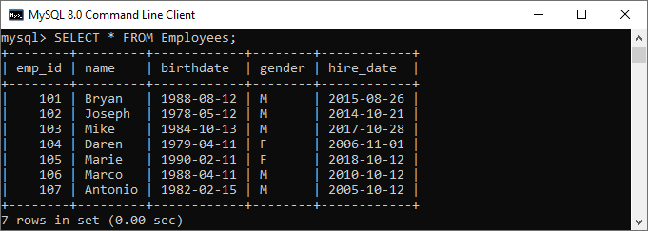  
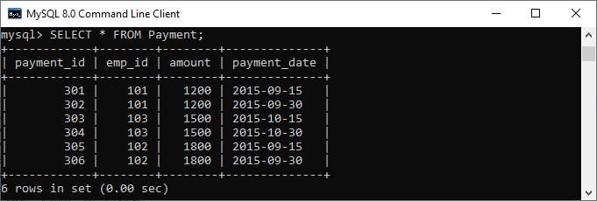

If we want to delete an employee whose **emp_id is 107**, we should use the DELETE statement with the WHERE clause. See the below query:

1. mysql> **DELETE** **FROM** Employees **WHERE** emp_id=107;

After the execution of the query, it will return the output as below image. Once the record is deleted, verify the table using the [SELECT statement](https://www.javatpoint.com/mysql-select):

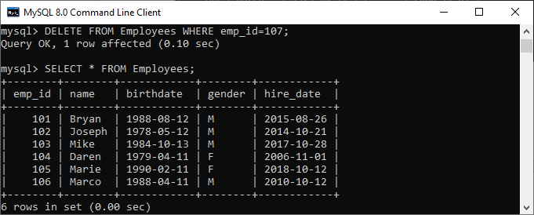

If we want to delete all records from the table, there is no need to use the WHERE clause with the DELETE statement. See the below code and output:

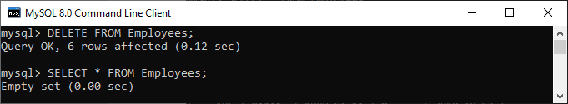

In the above output, we can see that after removing all rows, the Employees table will be empty. It means no records available in the selected table.

MySQL DELETE and LIMIT Clause

MySQL Limit clause is used to restrict the count of rows returns from the result set, rather than fetching the whole records in the table. Sometimes we want to limit the number of rows to be deleted from the table; in that case, we will use the [LIMIT](https://www.javatpoint.com/mysql-limit) clause as follows:

1. **DELETE** **FROM** table_name
2. **WHERE** condition
3. **ORDER** **BY** colm1, colm2, ...
4. LIMIT row_count;

It is to note that the order of rows in a MySQL table is unspecified. Therefore, we should always use the **ORDER BY** clause while using the LIMIT clause.

**For example**, the following query first sorts the employees according to their names alphabetically and deletes the first three employees from the table:

1. mysql> **DELETE** **FROM** Employees **ORDER** **BY** **name** LIMIT 3;

It will give the below output:

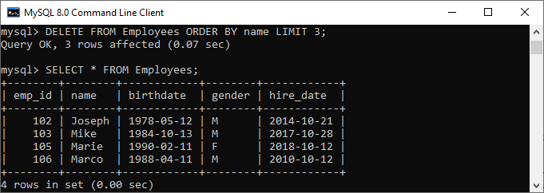

MySQL DELETE and JOIN Clause

The JOIN clause is used to add the two or more tables in MySQL. We will add the JOIN clause with the DELETE statement whenever we want to delete records from multiple tables within a single query. See the below query:

1. mysql> **DELETE** Employees, Payment **FROM** Employees
2. **INNER** JOIN Payment
3. **ON** Employees.emp_id = Payment.emp_id
4. **WHERE** Employees.emp_id = 102;

**Output:**

After execution, we will see the output as below image:

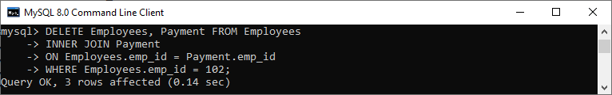

# MySQL SELECT Statement

The SELECT statement in MySQL is used to **fetch data from one or more tables**. We can retrieve records of all fields or specified fields that match specified criteria using this statement. It can also work with various scripting languages such as [PHP](https://www.javatpoint.com/php-tutorial), [Ruby](https://www.javatpoint.com/ruby-tutorial), and many more.

## **SELECT Statement Syntax**

It is the most commonly used [SQL](https://www.javatpoint.com/sql-tutorial) query. The general syntax of this statement to fetch data from tables are as follows:

1. **SELECT** field_name1, field_name 2,... field_nameN
2. **FROM** table_name1, table_name2...
3. [**WHERE** condition]
4. [**GROUP** **BY** field_name(s)]
5. [**HAVING** condition]
6. [**ORDER** **BY** field_name(s)]
7. [OFFSET M ][LIMIT N];

### Syntax for all fields:

1. **SELECT** * **FROM** tables [**WHERE** conditions]
2. [**GROUP** **BY** fieldName(s)]
3. [**HAVING** condition]
4. [**ORDER** **BY** fieldName(s)]
5. [OFFSET M ][LIMIT N];

## **Parameter Explanation**

The SELECT statement uses the following parameters:

|  |  |
| --- | --- |
| **Parameter Name** | **Descriptions** |
| field_name(s) or * | It is used to specify one or more columns to returns in the result set. The asterisk (*) returns all fields of a table. |
| table_name(s) | It is the name of tables from which we want to fetch data. |
| WHERE | It is an optional clause. It specifies the condition that returned the matched records in the result set. |
| GROUP BY | It is optional. It collects data from multiple records and grouped them by one or more columns. |
| HAVING | It is optional. It works with the GROUP BY clause and returns only those rows whose condition is TRUE. |
| ORDER BY | It is optional. It is used for sorting the records in the result set. |
| OFFSET | It is optional. It specifies to which row returns first. By default, It starts with zero. |
| LIMIT | It is optional. It is used to limit the number of returned records in the result set. |

#### NOTE: It is to note that MySQL always evaluates the FROM clause first, and then the SELECT clause will be evaluated.

### MySQL SELECT Statement Example:

Let us understand how SELECT command works in [MySQL](https://www.javatpoint.com/mysql-tutorial) with the help of various examples. Suppose we have a table named **employee_detail** that contains the following data:

Play Video

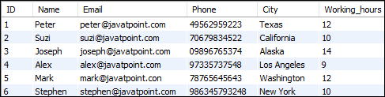

**1.** If we want to retrieve a **single column from the table**, we need to execute the below query:

1. mysql> **SELECT** **Name** **FROM** employee_detail;

We will get the below output where we can see only one column records.

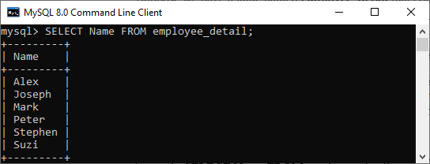

**2.** If we want to query **multiple columns from the table**, we need to execute the below query:

1. mysql> **SELECT** **Name**, Email, City **FROM** employee_detail;

We will get the below output where we can see the name, email, and city of employees.

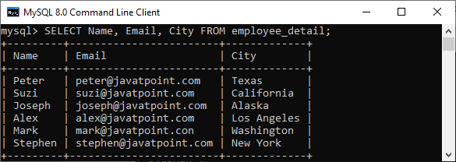

**3.** If we want to fetch data from **all columns of the table**, we need to use all column's names with the select statement. Specifying all column names is not convenient to the user, so MySQL uses an **asterisk** (*) to retrieve all column data as follows:

1. mysql> **SELECT** * **FROM** employee_detail;

We will get the below output where we can see all columns of the table.

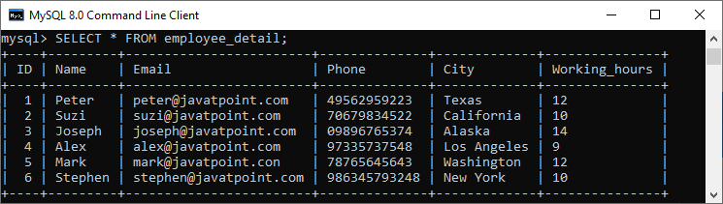

**4.** Here, we use the **SUM function** with the [**HAVING** clause](https://www.javatpoint.com/mysql-having) in the SELECT command to get the employee name, city, and total working hours. Also, it uses the [**GROUP BY** clause](https://www.javatpoint.com/mysql-group-by) to group them by the Name column.

1. **SELECT** **Name**, City, SUM(working_hours) **AS** "Total working hours"
2. **FROM** employee_detail
3. **GROUP** **BY** **Name**
4. **HAVING** SUM(working_hours) > 5;

It will give the below output:

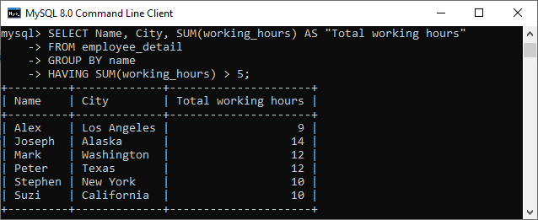

**5.** MySQL SELECT statement can also be used to retrieve records from multiple tables by using a **JOIN statement**. Suppose we have a table named **"customer"** and **"orders"** that contains the following data:

**Table: customer**

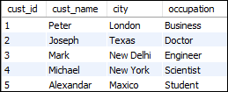

**Table: orders**

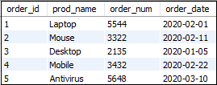

Execute the following SQL statement that returns the matching records from both tables using the [**INNER JOIN** query](https://www.javatpoint.com/mysql-inner-join):

1. **SELECT** cust_name, city, order_num, order_date
2. **FROM** customer **INNER** JOIN orders
3. **ON** customer.cust_id = orders.order_id
4. **WHERE** order_date < '2020-04-30'
5. **ORDER** **BY** cust_name;

After successful execution of the query, we will get the output as follows:

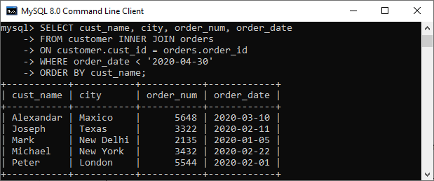

MySQL DESCRIBE TABLE

DESCRIBE means to show the information in detail. Since we have tables in MySQL, so we will use the **DESCRIBE command to show the structure of our table**, such as column names, constraints on column names, etc. The **DESC** command is a short form of the DESCRIBE command. Both DESCRIBE and DESC command are equivalent and case sensitive.

Syntax

The following are the syntax to display the table structure:

1. {DESCRIBE | **DESC**} table_name;

**We can use the following steps to show all columns of the table**:

**Step 1:** Login into the MySQL database server.

Play Video

**Step 2:** Switch to a specific database.

**Step 3:** Execute the DESCRIBE statement.

Let us understand it with the help of an example that explains how to show columns of the table in the selected database.

Login to the MySQL Database

The first step is to login to the database server using the **username** and **password**. We should see the output as below image:

1. >mysql -u root -p
2. Enter **password**: **********
3. mysql>

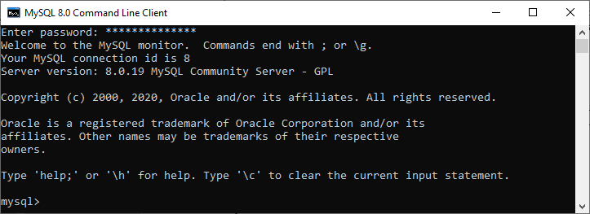

Switch to a Specific Database

The next step is to open a particular database from which you want to display the table information using the following query. After the execution of a query, we should see the below output:

1. mysql> USE mysqltestdb;

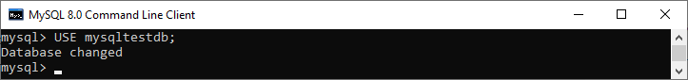

Execute DESCRIBE Statement

It is the last step to display the table information. Before executing the DESCRIBE statement, we can optionally display all the tables stored in our selected database with the [**SHOW TABLES** statement](https://www.javatpoint.com/mysql-show-list-tables):

1. mysql> SHOW TABLES;

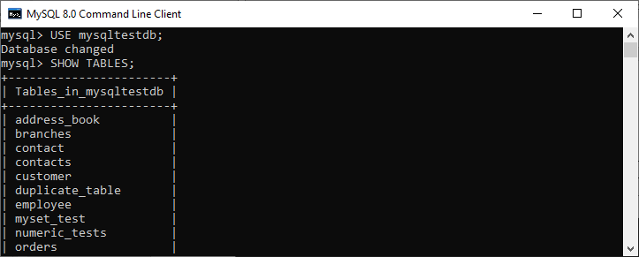

**For example**, if we want to show a **customer table's structure**, execute the below statement. After successful execution, it will give the output as below image:

1. mysql> DESCRIBE customer;

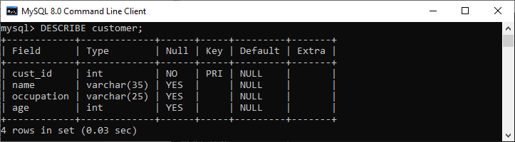

We can also use the DESC statement for practice, which is a shorthand of the DESCRIBE command. See the below output:

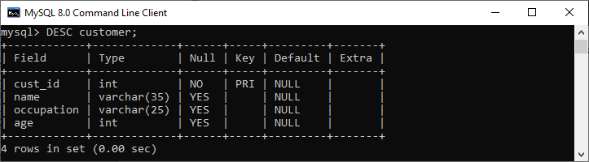

How to display table information in MySQL Workbench?

To display the column information of the table in [MySQL Workbench](https://www.javatpoint.com/mysql-workbench), we first need to launch the Workbench tool and login with the username and password to the [MySQL](https://www.javatpoint.com/mysql-tutorial) database server. We will get the following screen:

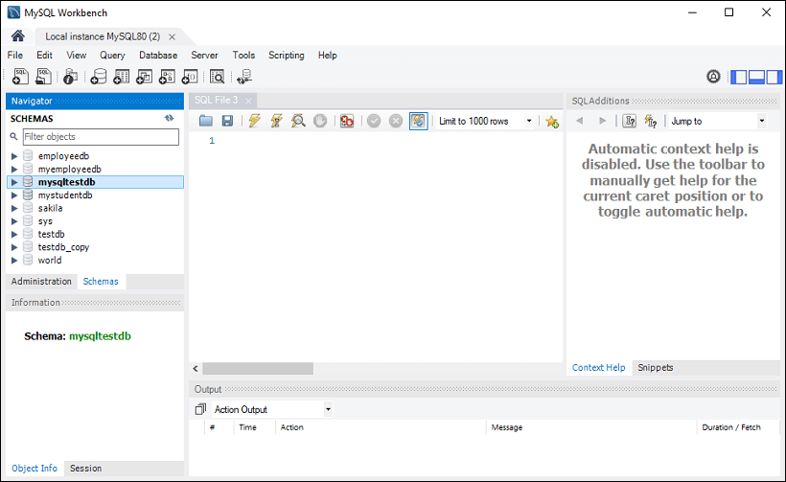

Now do the following steps to show the table information:

1. Go to the **Navigation tab** and click on the **Schema menu**. Here, we can see all the previously created databases. Select any database under the Schema menu, for example, **mysqltestdb**. It will pop up the multiple options that can be shown in the following image.

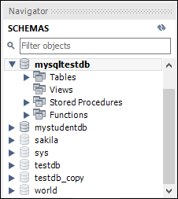

2. Next, click on the "**Tables**" that shows all tables stored in the mysqltestdb database. Select a table whose column information you want to display. Then, mouse hour on that table, it will show **three icons**. See the below image:

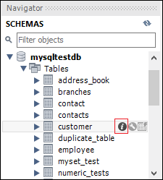

Now, click the **icon (i)** shown in the red rectangular box. It will display the following image:

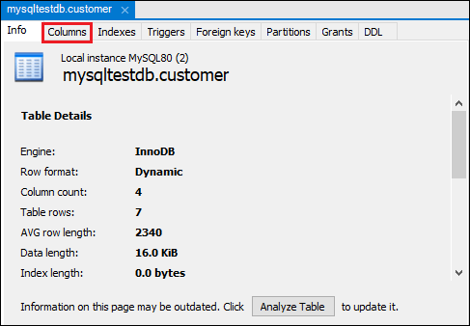

Finally, click on the "**Columns**" menu to display the table structure.

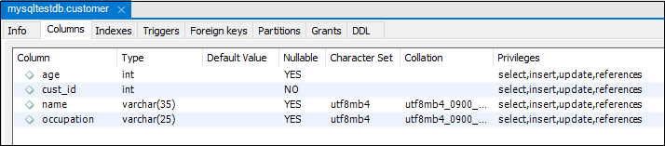

MySQL SHOW COLUMNS Command

MySQL also allows the SHOW COLUMNS command to display table structure. It is a more flexible way to get columns information of a table.

**Syntax:**

The following are the syntax of the SHOW COLUMNS command:

1. mysql> SHOW COLUMNS **FROM** table_name;

**For example**, if we execute the below query, we will get all columns information of a table in a particular database:

1. mysql> SHOW COLUMNS **FROM** customer;

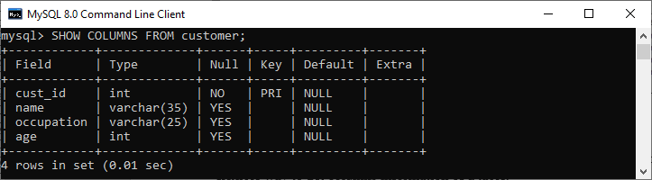

If we want to show the **columns information of a table from another database** or not available in the current database, we can use the following query:

1. mysql> SHOW COLUMNS **FROM** database_name.table_name;
3. OR
5. mysql> SHOW COLUMNS **FROM** table_name IN database_name;

In the below image, we can see that we had used the mysqltestdb database. But we had displayed the column's information of a table from another database without switching to the current database.

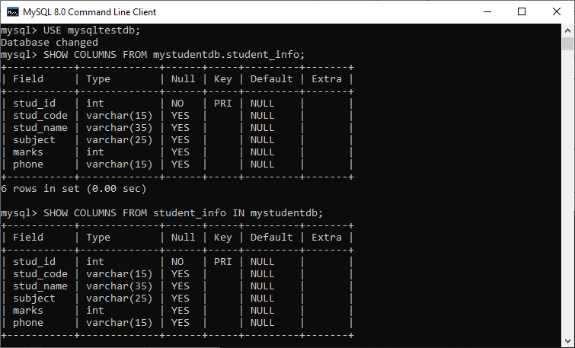

If we want to display the more column information, we need to add **FULL** keyword with the SHOW TABLES statement as follows:

1. mysql> SHOW **FULL** COLUMNS **FROM** table_name;

**For example**, the below SQL query lists all columns of the **student_info table** in the **mystudentdb database**:

1. mysql> SHOW **FULL** COLUMNS **FROM** student_info;

After execution, we can see that this command adds the **collation, privileges, default**, and **comment** columns to the result set.

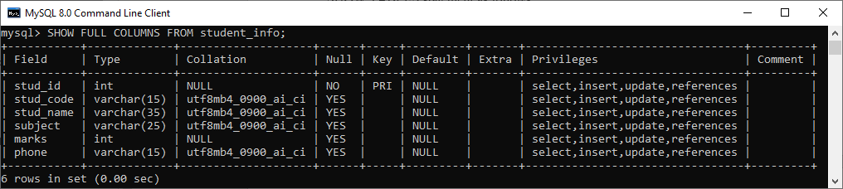

MySQL EXPLAIN

The EXPLAIN keyword is synonyms to the DESCRIBE statement, which is **used to obtain information about how MySQL executes the queries**. It can work with [INSERT](https://www.javatpoint.com/mysql-insert), [SELECT](https://www.javatpoint.com/mysql-select), [DELETE](https://www.javatpoint.com/mysql-delete), [UPDATE](https://www.javatpoint.com/mysql-update), and [REPLACE queries](https://www.javatpoint.com/mysql-replace). From **MySQL 8.0.19** and later versions, it can also work with TABLE statements. When we use this keyword in queries, it will process the statement and provide the information about how tables are joined, the order of the table, estimated partitions and rows.

**Example**

If we want to show the execution plan of a **SELECT statement**, we can use the query as below:

1. mysql> EXPLAIN **SELECT** * **FROM** customer;

**Output:**

This query produces the following information:

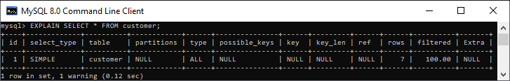

MySQL Constraints

The constraint in MySQL is used to specify the rule that allows or restricts what values/data will be stored in the table. They provide a suitable method to ensure data accuracy and integrity inside the table. It also helps to limit the type of data that will be inserted inside the table. If any interruption occurs between the constraint and data action, the action is failed.

Types of MySQL Constraints

Constraints in MySQL is classified into two types:

1. **Column Level Constraints:** These constraints are applied only to the single column that limits the type of particular column data.
2. **Table Level Constraints:** These constraints are applied to the entire table that limits the type of data for the whole table.

How to create constraints in MySQL

We can define the constraints during a table created by using the CREATE TABLE statement. MySQL also uses the ALTER TABLE statement to specify the constraints in the case of the existing table schema.

Syntax

The following are the syntax to create a constraints in table:

1.4M

Elon Musk wants all Twitter employees to email him with a weekly update on their work

1. **CREATE** **TABLE** new_table_name (
2. col_name1 datatype **constraint**,
3. col_name2 datatype **constraint**,
4. col_name3 datatype **constraint**,
5. .........
6. );

Constraints used in MySQL

The following are the most common constraints used in the MySQL:

* NOT NULL
* CHECK
* DEFAULT
* PRIMARY KEY
* AUTO_INCREMENT
* UNIQUE
* INDEX
* ENUM
* FOREIGN KEY

Let us discuss each of these constraints in detail.

NOT NULL Constraint

This constraint specifies that the column cannot have NULL or empty values. The below statement creates a table with NOT NULL constraint.

1. mysql> **CREATE** **TABLE** Student(Id **INTEGER**, LastName TEXT NOT NULL, FirstName TEXT NOT NULL, City **VARCHAR**(35));

Execute the queries listed below to understand how it works:

1. mysql> **INSERT** **INTO** Student **VALUES**(1, 'Hanks', 'Peter', 'New York');
3. mysql> **INSERT** **INTO** Student **VALUES**(2, NULL, 'Amanda', 'Florida');

**Output**

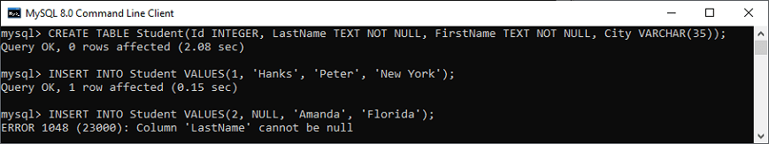

In the above image, we can see that the first INSERT query executes correctly, but the second statement fails and gives an error that says column LastName cannot be null.

UNIQUE Constraint

This constraint ensures that all values inserted into the column will be unique. It means a column cannot stores duplicate values. MySQL allows us to use more than one column with UNIQUE constraint in a table. The below statement creates a table with a UNIQUE constraint:

1. mysql> **CREATE** **TABLE** ShirtBrands(Id **INTEGER**, BrandName **VARCHAR**(40) **UNIQUE**, **Size** **VARCHAR**(30));

Execute the queries listed below to understand how it works:

1. mysql> **INSERT** **INTO** ShirtBrands(Id, BrandName, **Size**) **VALUES**(1, 'Pantaloons', 38), (2, 'Cantabil', 40);
3. mysql> **INSERT** **INTO** ShirtBrands(Id, BrandName, **Size**) **VALUES**(1, 'Raymond', 38), (2, 'Cantabil', 40);

**Output**

In the below output, we can see that the first INSERT query executes correctly, but the second statement fails and gives an error that says: Duplicate entry 'Cantabil' for key BrandName.

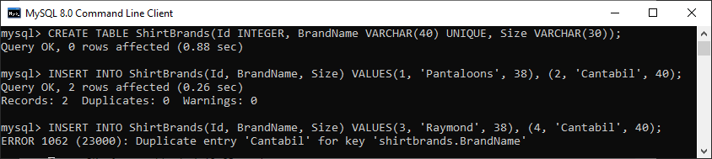

CHECK Constraint

It controls the value in a particular column. It ensures that the inserted value in a column must be satisfied with the given condition. In other words, it determines whether the value associated with the column is valid or not with the given condition.

Before the version 8.0.16, MySQL uses the limited version of this constraint syntax, as given below:

1. **CHECK** (expr)

After the version 8.0.16, MySQL uses the CHECK constraints for all storage engines i.e., table constraint and column constraint, as given below:

1. [**CONSTRAINT** [symbol]] **CHECK** (expr) [[NOT] ENFORCED]

Let us understand how a CHECK constraint works in MySQL. For example, the following statement creates a table "Persons" that contains CHECK constraint on the "Age" column. The CHECK constraint ensures that the inserted value in a column must be satisfied with the given condition means the Age of a person should be greater than or equal to 18:

1. mysql> **CREATE** **TABLE** Persons (
2. ID **int** NOT NULL,
3. **Name** **varchar**(45) NOT NULL,
4. Age **int** **CHECK** (Age>=18)
5. );

Execute the listed queries to insert the values into the table:

1. mysql> **INSERT** **INTO** Persons(Id, **Name**, Age)
2. **VALUES** (1,'Robert', 28), (2, 'Joseph', 35), (3, 'Peter', 40);
4. mysql> **INSERT** **INTO** Persons(Id, **Name**, Age) **VALUES** (1,'Robert', 15);

**Output**

In the below output, we can see that the first INSERT query executes successfully, but the second statement fails and gives an error that says: CHECK constraint is violated for key Age.

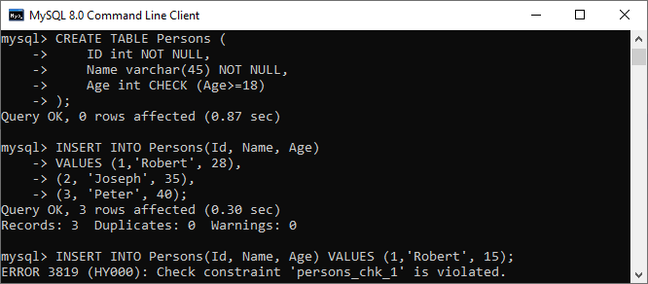

DEFAULT Constraint

This constraint is used to set the default value for the particular column where we have not specified any value. It means the column must contain a value, including NULL.

For example, the following statement creates a table "Persons" that contains DEFAULT constraint on the "City" column. If we have not specified any value to the City column, it inserts the default value:

1. mysql> **CREATE** **TABLE** Persons (
2. ID **int** NOT NULL,
3. **Name** **varchar**(45) NOT NULL,
4. Age **int**,
5. City **varchar**(25) **DEFAULT** 'New York'
6. );

Execute the listed queries to insert the values into the table:

1. mysql> **INSERT** **INTO** Persons(Id, **Name**, Age, City)
2. **VALUES** (1,'Robert', 15, 'Florida'),
3. (2, 'Joseph', 35, 'California'),
4. (3, 'Peter', 40, 'Alaska');
6. mysql> **INSERT** **INTO** Persons(Id, **Name**, Age) **VALUES** (1,'Brayan', 15);

**Output**

In the below output, we can see that the first insert query that contains all fields executes successfully, while the second insert statement does not contain the "City" column but also executed successfully. It is because it has a default value.

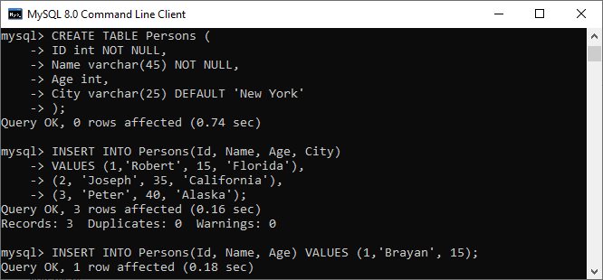

Now, executes the following statement to validate the default value for the 4th column:

1. mysql> **SELECT** * **FROM** Persons;

We can see that it works perfectly. It means default value "New York" stored automatically in the City column.

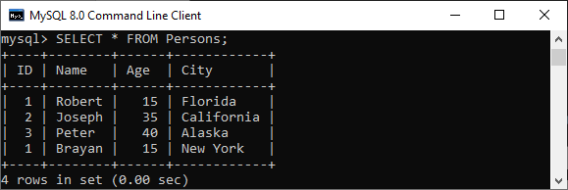

PRIMARY KEY Constraint

This constraint is used to identify each record in a table uniquely. If the column contains primary key constraints, then it cannot be null or empty. A table may have duplicate columns, but it can contain only one primary key. It always contains unique value into a column.

The following statement creates a table "Person" and explains the use of this primary key more clearly:

1. **CREATE** **TABLE** Persons (
2. ID **int** NOT NULL **PRIMARY** **KEY**,
3. **Name** **varchar**(45) NOT NULL,
4. Age **int**,
5. City **varchar**(25));

Next, use the insert query to store data into a table:

1. **INSERT** **INTO** Persons(Id, **Name**, Age, City)
2. **VALUES** (1,'Robert', 15, 'Florida') ,
3. (2, 'Joseph', 35, 'California'),
4. (3, 'Peter', 40, 'Alaska');
6. **INSERT** **INTO** Persons(Id, **Name**, Age, City)
7. **VALUES** (1,'Stephen', 15, 'Florida');

**Output**

In the below output, we can see that the first insert query executes successfully. While the second insert statement fails and gives an error that says: Duplicate entry for the primary key column.

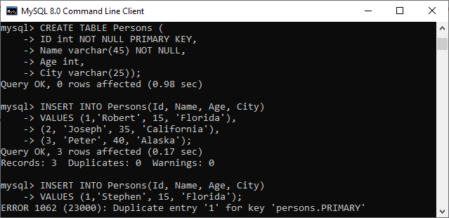

AUTO_INCREMENT Constraint

This constraint automatically generates a unique number whenever we insert a new record into the table. Generally, we use this constraint for the primary key field in a table.

We can understand it with the following example where the id column going to be auto-incremented in the Animal table:

1. mysql> **CREATE** **TABLE** Animals(
2. id **int** NOT NULL AUTO_INCREMENT,
3. **name** **CHAR**(30) NOT NULL,
4. **PRIMARY** **KEY** (id));

Next, we need to insert the values into the "Animals" table:

1. mysql> **INSERT** **INTO** Animals (**name**) **VALUES**
2. ('Tiger'),('Dog'),('Penguin'),
3. ('Camel'),('Cat'),('Ostrich');

Now, execute the below statement to get the table data:

1. mysql> **SELECT** * **FROM** Animals;

**Output**

In the output, we can see that I have not specified any value for the auto-increment column, so MySQL automatically generates a unique number in the sequence order for this field.

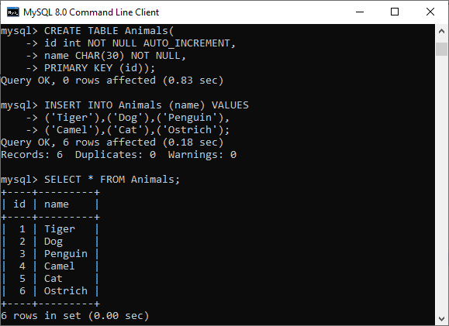

ENUM Constraint

The ENUM data type in MySQL is a string object. It allows us to limit the value chosen from a list of permitted values in the column specification at the time of table creation. It is short for enumeration, which means that each column may have one of the specified possible values. It uses numeric indexes (1, 2, 3…) to represent string values.

The following illustration creates a table named "shirts" that contains three columns: id, name, and size. The column name "size" uses the ENUM data type that contains small, medium, large, and x-large sizes.

1. mysql> **CREATE** **TABLE** Shirts (
2. id **INT** **PRIMARY** **KEY** AUTO_INCREMENT,
3. **name** **VARCHAR**(35),
4. **size** ENUM('small', 'medium', 'large', 'x-large')
5. );

Next, we need to insert the values into the "Shirts" table using the below statements:

1. mysql> **INSERT** **INTO** Shirts(id, **name**, **size**)
2. **VALUES** (1,'t-shirt', 'medium'),
3. (2, 'casual-shirt', 'small'),
4. (3, 'formal-shirt', 'large');

Now, execute the SELECT statement to see the inserted values into the table:

1. mysql> **SELECT** * **FROM** Shirts;

**Output**

We will get the following output:

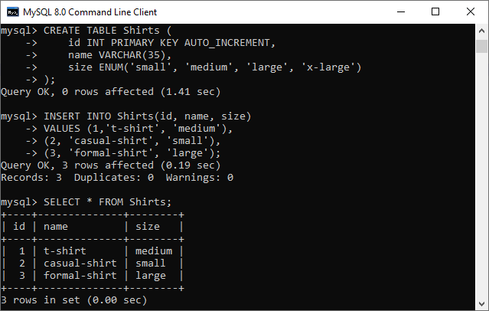

INDEX Constraint

This constraint allows us to create and retrieve values from the table very quickly and easily. An index can be created using one or more than one column. It assigns a ROWID for each row in that way they were inserted into the table.

The following illustration creates a table named "shirts" that contains three columns: id, name, and size.

1. mysql> **CREATE** **TABLE** Shirts (
2. id **INT** **PRIMARY** **KEY** AUTO_INCREMENT,
3. **name** **VARCHAR**(35),
4. **size** ENUM('small', 'medium', 'large', 'x-large')
5. );

Next, we need to insert the values into the "Shirts" table using the below statements:

1. mysql> **INSERT** **INTO** Shirts(id, **name**, **size**)
2. **VALUES** (1,'t-shirt', 'medium'),
3. (2, 'casual-shirt', 'small'),
4. (3, 'formal-shirt', 'large');

Now, execute this statement for creating index:

1. mysql> **CREATE** **INDEX** idx_name **ON** Shirts(**name**);

We can use the query below to retrieve the data using the index column:

1. mysql> **SELECT** * **FROM** Shirts USE **INDEX**(idx_name);

**Output**

The following output appears:

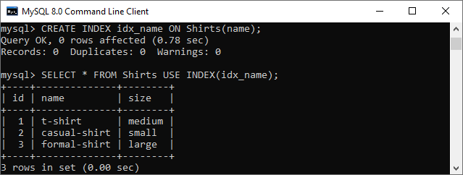

Foreign Key Constraint

This constraint is used to link two tables together. It is also known as the referencing key. A foreign key column matches the primary key field of another table. It means a foreign key field in one table refers to the primary key field of another table.

Let us consider the structure of these tables: Persons and Orders.

**Table: Persons**

1. **CREATE** **TABLE** Persons (
2. Person_ID **int** NOT NULL **PRIMARY** **KEY**,
3. **Name** **varchar**(45) NOT NULL,
4. Age **int**,
5. City **varchar**(25)
6. );

**Table: Orders**

1. **CREATE** **TABLE** Orders (
2. Order_ID **int** NOT NULL **PRIMARY** **KEY**,
3. Order_Num **int** NOT NULL,
4. Person_ID **int**,
5. **FOREIGN** **KEY** (Person_ID) **REFERENCES** Persons(Person_ID)
6. );

In the above table structures, we can see that the "Person_ID" field in the "Orders" table points to the "Person_ID" field in the "Persons" table. The "Person_ID" is the PRIMARY KEY in the "Persons" table, while the "Person_ID" column of the "Orders" table is a FOREIGN KEY.

**Output**

Our table contains the following data:

